Visual Arts
Student’s name
Institutional affiliation
Course

Visual Arts
KB24 by Justin Jacobs
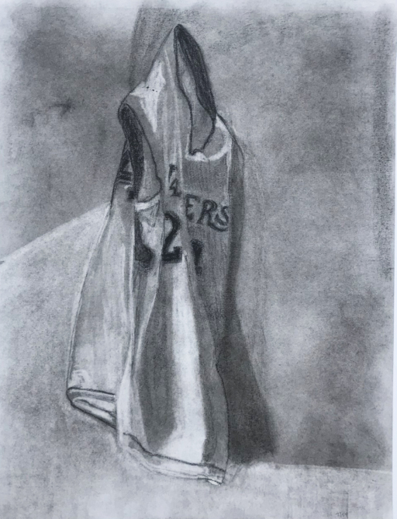
KB24 by Justin Jacobs, Charcoal.
What drew my attention to this artwork was the emotion that it portrayed. The artist was trying to pay tribute to the basketball player Kobe Bryant who passed away earlier this year. Clearly, the player meant a lot to the artist and the world in general if the number of moving tributes that have been made to him is anything to go by. The artist achieves Kobe Bryant's tribute with this artwork. It is dark and has an awry feeling that is very vivid.
The artist specifically draws the basketball jersey as being hung up. This is symbolic in that it portrays that not only did Kobe Bryant end any basketball-related activities, but also lost his life. Although we cannot see the jersey numbers very well, it comes out very clearly that this is Kobe Bryant's jersey because the number 2 is visible.
This photo has a sorrowful feel to it but also has a tribute like impression. It says that the player will live forever, through the many memories that he shared during his career that spanned more than two decades. The artist also uses the jersey that is associated with the National Basketball League team, the Los Angeles Lakers because people remember him most from his playing days in that team. The number 2 is clearly shown by the artist. This number also happens to be in the Fibonacci sequence. Whether this was intentional or not, the artist brought the message home that Kobe will be missed, and dearly he will.
I thought this picture’s style was simple, yet so comprehensible. It acknowledged that although his death was a tragic occurrence, his legacy will live forever. Furthermore, it pointed out that his legendary status is cemented because people will always think about him when they see the Los Angeles jersey.

Pandemic Shock by Mariana Ortiz
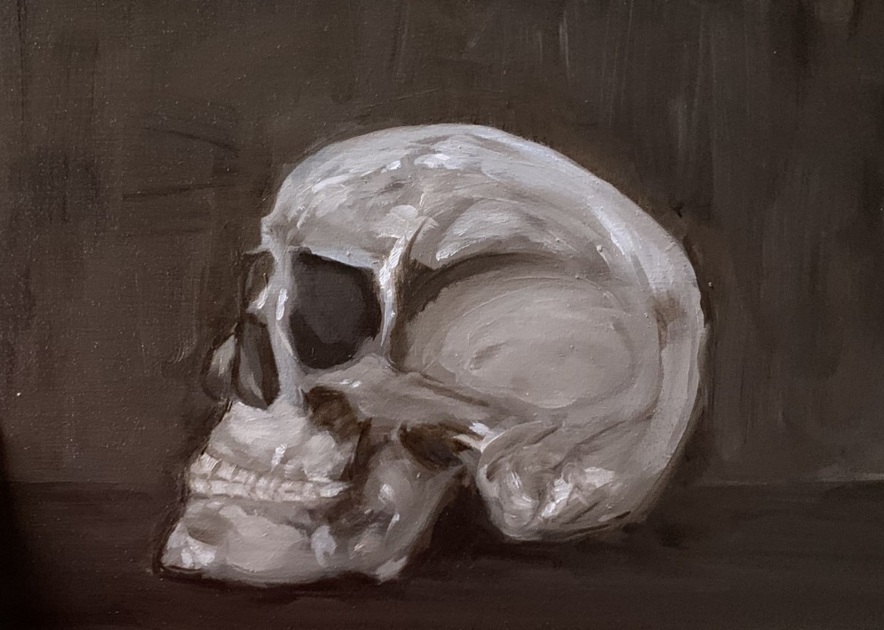
Pandemic Shock by Mariana Ortiz, Oil.
What drew my attention to this artwork was the skull drawn. The artist intended to portray an imminent danger that had deadly consequences. Furthermore, I think that the artist portrayed the skull as a warning to people that they need to tread carefully around a particular mayhem. The artist achieved in depicting danger as this skull drives the point home that there is an imminent danger lurking about. The simple yet vivid description of death is obvious. The fear that this artwork conveys is palpable.
The symbolism used in this artwork is quite clear. The bare skull portrays danger. From the artwork’s name, “Pandemic Shock” the message that the artist intended to communicate is very clear. The novel COVID-19, better known as coronavirus has ravaged, the world for the better part of the year. It has left its mark on all or almost every country in the world. It is fatal and has claimed well over one million lives so far. In essence, the artist wanted to communicate that we had better protect ourselves from this pandemic lest we end up as skulls and skeletons.
I loved this artwork as I felt it had a very clear message about our own safety. It was simple yet quite clear. At a time when many people are not taking these precautions seriously, it drove the message home that the disease will strike at anyone unabated lest we take care of ourselves. Furthermore, the fragility of human lives was highlighted. Our lives are so fragile, and can end so swiftly. We are subject to the whims of nature and as such, if we can be able to prevent tragedies from happening to us, we had better start doing so lest we end up as skulls.

Reference
Unprecedented. Santafecollegeartgallery.com. (2020). Retrieved 26 September 2020, from https://santafecollegeartgallery.com/#jp-carousel-213.

Footnotes
1[Add footnotes, if any, on their own page following references. For APA formatting requirements, it’s easy to just type your own footnote references and notes. To format a footnote reference, select the number and then, on the Home tab, in the Styles gallery, click Footnote Reference. The body of a footnote, such as this example, uses the Normal text style. (Note: If you delete this sample footnote, don’t forget to delete its in-text reference as well. That’s at the end of the sample Heading 2 paragraph on the first page of body content in this template.)]

Tables
Table 1
[Table Title]
Column Head | Column Head | Column Head | Column Head | Column Head
Row Head | 123 | 123 | 123 | 123
Row Head | 456 | 456 | 456 | 456
Row Head | 789 | 789 | 789 | 789
Row Head | 123 | 123 | 123 | 123
Row Head | 456 | 456 | 456 | 456
Row Head | 789 | 789 | 789 | 789
Note: [Place all tables for your paper in a tables section, following references (and, if applicable, footnotes). Start a new page for each table, include a table number and table title for each, as shown on this page. All explanatory text appears in a table note that follows the table, such as this one. Use the Table/Figure style, available on the Home tab, in the Styles gallery, to get the spacing between table and note. Tables in APA format can use single or 1.5 line spacing. Include a heading for every row and column, even if the content seems obvious. A default table style has been setup for this template that fits APA guidelines. To insert a table, on the Insert tab, click Table.]

Figures title:

Figure 1. [Include all figures in their own section, following references (and footnotes and tables, if applicable). Include a numbered caption for each figure. Use the Table/Figure style for easy spacing between figure and caption.]
For more information about all elements of APA formatting, please consult the APA Style Manual, 6th Edition.

